**484 Enterprise Drive**

**Gassaway, WV 26624**

**(304)364-5518**

**www.mountaineerfoodbank.org**

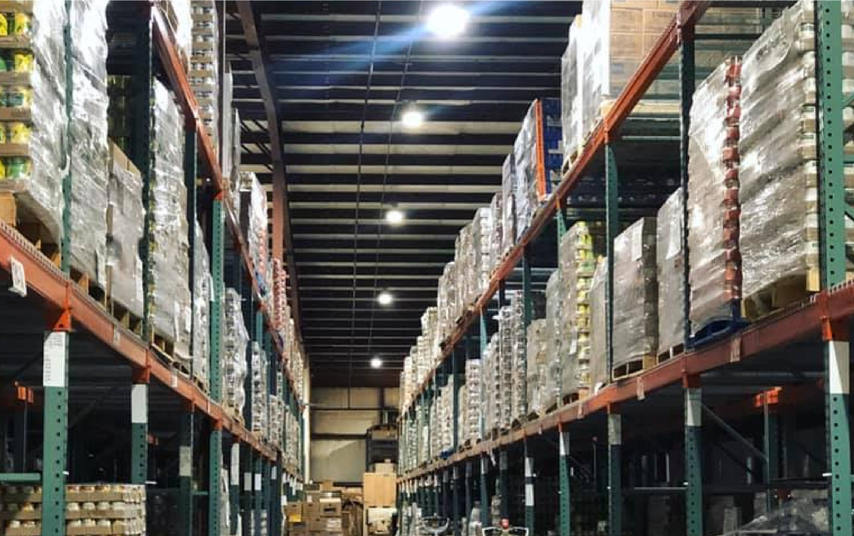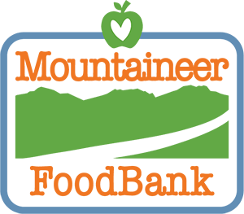

ARPA

PROPOSAL

***MOUNTAINEER FOOD***

***BANK***

Executive Summary

For 40 years, Mountaineer Food Bank has been one of the cornerstone organizations addressing food insecurity in West Virginia. As one of the two Feeding America food banks, MFB provides food into 48 of the 55 counties in West Virginia. It has grown from having one small warehouse in downtown Gassaway, to currently owning one 25,000 square foot facility and leasing almost 75,000 square feet of additional space. In 2020, MFB sustained West Virginia with almost 25 million meals to over 260,000 hungry neighbors. Sadly, the COVID-19 pandemic was not the main cause of this work, as in 2019 MFB delivered 18 million meals to over 240,000 folks.

Hunger in West Virginia is a chronic health crisis, which can be solved, but only through the compound work of both feeding and shortening the line. Critical infrastructure such as a strong central distribution center along with community food hubs will go a significant distance in meeting the needs of hungry West Virginians. Investment in program services that target vulnerable populations and communities is essential to moving hungry individuals toward healthier, happier lives. By investing in programs like the Veterans Table and Feeding Families Prime, we are creating pathways for the food insecure to take steps forward.

Finally, to shorten the line, West Virginia needs sound investment in agriculture programs that strengthen food insecurity. Surrounding states have strong Farm to Food Bank programs that benefit seasoned and upcoming food producers, while providing local foods into food banks. West Virginia has an opportunity to catch up and surpass these states by investing dollars directly into the state. A Farm to Food Bank program could increase the capacity of production planning, strengthening logistics, secure our supply chain in the state and reduce our dependency on foods from our of our state.

West Virginia has 242,000 individuals that suffer from chronic food insecurity. These totals including over 68,000 children, 30,000 seniors and almost 10,000 veterans. The hunger people feel today will not go away with just policy changes, but with a complex mixture of policy, program services and infrastructure investment, West Virginia may have the capability to shift food insecurity work in a positive manner for generations.

In order to move towards our goal of a hunger-free West Virginia, Mountaineer Food Bank (MFB) will be requesting investments in 3 key areas: critical infrastructure, program services for vulnerable populations and policy investments for sustainable food access. The investments' impacts range from transformative to patchwork. Together, the investments will position West Virginia with resources and infrastructure to tackle hunger in an unprecedented way.



Critical Infrastructure

Mountaineer Food Bank has always been involved in the collection, storage and distribution of large volumes of food in West Virginia. Since 1981, MFB has operated as a Feeding America food bank, providing food into 48 counties of the state. Since 1997, MFB has operated from a 25,000 sq. ft. facility in Gassaway, WV, which provides a central aggregation point in the state, with easy access to I-79 and major population centers in WV.

Food banking has changed dramatically since the late 90’s and a facility built for distributing 10 million pounds annually is now tasked with distributing 20-30 million pounds each year.

Food banks operate with a complex mix of donated, purchased and commodity foods, which means that the aggregation/distribution works best when centrally aggregated and then disbursed to hubs/member agencies. Member agencies are considered food pantries, hot meal programs and other community based programs that provide food. In order to maximize the ability to source and distribute foods, MFB must have adequate space at the main facility for storage and distribution. Without adequate storage, the food system begins to either decline food opportunities or move them through at a pace that’s not ideal for food access.

Additionally, the types of food being distributed has shifted from shelf-stable to highly perishable, increasing the need for multiple community food hubs of aggregation/distribution to match the timing for logistics and access in the food system of West Virginia. Hubs can also provide opportunities for additional direct services (food programs for children, seniors, veterans, chronically ill), workforce partnerships, disaster relief centers and much more.

As the COVID-19 pandemic began and continues, West Virginia became more vulnerable and exposed to future food and supply chain issues due to this lack of physical infrastructure. MFB is proposing the following steps in order to strengthen this food system for the next generation or more:

MFB has four main infrastructure targets that we request investment, in order of priority:

1. *Expansion of Gassaway Facility*

The expansion of MFB’s main facility is a high priority that must be addressed to secure food insecurity needs in the future of West Virginia. The current facility lacks adequate refrigerated/frozen storage and dry storage in order to continue sourcing high levels of donated product and manage windfall opportunities through The Emergency Food Assistance Program (TEFAP). MFB currently leases and additional 50,000 sq. ft. of dry space as a temporary measure.

MFB’s Gassaway facility needs an expansion of dry and cold storage up to an additional 75,000 sq. feet. This will adequately provide storage and operational space, sufficient offices, conference meeting rooms, a training kitchen and volunteer space. MFB currently employs 60 West Virginians, but anticipates that growing by 25-30 individuals in the next 3-5 years. These new employees will work in areas including food access, data/analytics, food sourcing, packaging and distribution. MFB currently leases 5,000 sq. feet in Flatwoods as office space for 20 employees.

Additional space will allow MFB the opportunity to be in more progressive collaborative partnerships with private entities for collection, storage and distribution of local foods. These partnerships, while being rare in the food bank space, would allow MFB to pilot innovation towards both strengthening food access and creating employment opportunities. An example would be our current partnership with the Turnrow Appalachian Farm Cooperative, where MFB aggregates, builds orders and delivers products from WV growers to retail grocery stores.

For an expansion, we estimate the total project to cost $9,350,000 for full completion. Costs include:

Site Work/Retaining Walls, Etc. = $1,650,000.00

Coolers/Freezers = $1,650,000.00

Minor Renovations to existing office area = $55,000.00

New Dry Storage & Volunteer Area = $ 3,000,000.00

New Classroom/Commercial Kitchen = $137,000.00

New Conference Center/Office Addition = $1,000,000.00

New Maintenance Bay = $100,000.00

Demo of Existing Freezers/Coolers = $25,000.00

Subtotal = $7,617,000.00

AE Fees @ 7.2% = $548,000.00

Furniture, Fixtures & Equipment = $250,000.00

Permits & Other Fees = $85,000.00

Project Contingency@ 10% = $850,000.00

**Grand Total = $9,350,000.00**

**Year 1 (2022)- Planning & Site Work- $1,735,000**

**Year 2 (2023)- Construction- $6,435,000**

**Year 3 (2024)- Finish- $1,180,000**

This project can move forward with partial funding. Mountaineer Food Bank is purposefully working toward funding from private sources, federal and the development of a capital campaign. MFB is currently working with a consulting firm and will target 2022-2023 to break ground on an expansion.

1. *Development of Morgantown Community Food Hub*

Morgantown provides an additional unique access point due to its reach for the Northern Panhandle and Eastern Panhandle, logistically for I-79, I-70 and I-68. This hub would be similar to Charleston, however, access to local produce, volunteers and collaboration for research with West Virginia University is also large-scale opportunities that drive this hub. MFB is targeting the development of a 10,000 sq. foot facility with dry and cold storage, with volunteer center that will allow MFB to achieve the following:

* Provide targeted program services to children, seniors, veterans and the chronic ill including:
  + Hot meal programs/Backpack Programming for children
  + Hot meal programs/Food box Programming for Senior Citizens
  + Hot meal programs/Veterans Table Food Box Programming for Veterans
  + Rx Food Box Programming for those with Chronic Illness (Rx provides food boxes with dietary specific foods, i.e. diabetic friendly food items).
* Create a safe space for workforce development, including packaging of food, hot meal preparation and delivery, and community development
* Create a hub for local feeding programs to access more food for community specific programs from our main facility in Gassaway.
* Create a safe volunteer space for youth and the community.
* Create a secondary point of aggregation for local producers to connect with other sites. Create between 5-10 full-time jobs.

Estimated cost is $1,500,000 million for project planning, development, and acquisition.

**Year 1 (2022)- Planning, Site Acquisition & Site Work- $200,000**

**Year 2 (2023)- Construction- $1,000,000**

**Year 3 (2024)- Finish- $300,00**

1. *Development of Charleston Community Food Hub*

Currently, MFB co-leases 10,000 sq. feet of dry space for food distribution in Poca, WV. The ideal situation for a community food hub in our heaviest populated food insecure county is a multi-function food hub more closely located to the City of Charleston. The development of a 10,000 sq. foot facility with dry and cold storage will allow MFB to achieve the following:

* Provide targeted program services to children, seniors, veterans and the chronic ill including:
  + Hot meal programs/Backpack Programming for children
  + Hot meal programs/Food box Programming for Senior Citizens
  + Hot meal programs/Veterans Table Food Box Programming for Veterans
  + Rx Food Box Programming for those with Chronic Illness (Rx provides food boxes with dietary specific foods, i.e. diabetic friendly food items).
* Create a safe space for workforce development, including packaging of food, hot meal preparation and delivery, and community development
* Create a hub for local feeding programs to access more food for community specific programs from our main facility in Gassaway.
* Create a safe volunteer space for youth and the community.
* Create a secondary point of aggregation for local producers to connect with other sites. Charleston provides a logistical access point for travel between I-79 and I-64.
* Create between 10-15 full-time jobs.

Estimated cost is $5,000,000 million for project planning, development and acquisition.

**Year 2 (2023)- Construction- $4,000,000**

**Year 3 (2024)- Finish- $500,00**

This project can move forward with partial funding and scaled down services. These costs estimates are to targeting meeting the needs of ALL food insecure veterans in West Virginia.

***The map below illustrates the potential locations of Mountaineer Food Bank throughout the state:***

Mountaineer Food Bank provides many population specific programs, however, the Veterans Table and Feeding Families Prime programs are unique in both West Virginia and mostly in a national area. The Veterans Table program targets vulnerable veterans that lack appropriate food access by partnering with the Veteran Affairs Medical Center (VAMC) in our area, including Beckley, Martinsburg and Clarksburg. The Veterans Table provides food boxes to up to 900 veterans each month.

Feeding Families Prime targets communities versus counties for more holistic community and feeding program services. Currently operating with six sites in West Virginia, Prime is focused on zip codes with the highest poverty, food insecurity, unemployment and lack of food access in the state. By focusing on communities, the services can go beyond just the surface of food, and provide access to drug treatment, job training, SNAP enrollment, nutrition education, medical services/counseling and much more. Prime sites serves between 600-850 individuals every two weeks providing these services, as well as, access to fresh foods.

For Program Services, we request investment in the following:

1. *Veterans Table Program*

West Virginia is proud of its Veteran population, however, almost 10% of the 100,000 veterans in West Virginia are food insecure. The partnership with local VMAC could immediately handle distribution to an additional 1,500 veterans each month, plus thousands that live farther away to regularly access the VMAC services. These veterans that live outside of the VMAC county benefit from Disabled American Veterans (DAV) vans that provide food and transportation for them. With appropriate funding, MFB can partner with VAMC, local veteran health clinics (CBOCs) and DAVs to reach large populations of veterans in rural communities.

The cost of providing a veteran household with a monthly food box is $300 annually, or an estimated $3 million per year to reach all 10,000. MFB is requesting an investment of $10 million in Veterans Table programming over the next 3 years. This will allow MFB to:

* Ensure that adequate and healthy food is provide into the Veteran Table program until 2025.
* Expand the program so that no Veteran lacks service, focusing on high population areas and partnerships such as with the VAMC/DAV to reach rural populations

**Year 1 (2022)- Expansion of program including delivery services - $3,000,000**

**Year 2 (2023)- Continued reach of services- $3,500,000**

**Year 3 (2024)- Reach of services completed- $3,500,000**

This project can move forward with partial funding and scaled down services. These costs estimates are to targeting meeting the needs of ALL food insecure veterans in West Virginia.

Program Services

1. *WV Farm to Food Banks Program*

West Virginia lacks a robust program that enables WV famers and producers to connect with the food banks system. States such as Kentucky, Pennsylvania and Ohio have strong agricultural programs that are tied in the seams of food banks and producers. Additionally, West Virginia relies heavily on foods from out of our state to feed: both at the market and through our food banks. This needs shifted.

A Farm to Food Banks program would allow food banks to purchase produce and/or reimburse farmers for the cost of picking, packaging, and transporting their number-2 grade produce to the two food banks in West Virginia.

Coupled with a stronger, more manageable Farm to Food Bank tax credit, producers in the state will be able to plan larger crop yields without the disadvantage of major losses if the market is not strong. Food banks are always searching for closer, better access to fresh produce. Additionally, there are annual federal dollars that could become available to support existing programs if developed through the Farm Bill.

Policy Investments

*2. Feeding Families Prime*

Feeding Families Prime sites are the future for smaller communities to develop food access for their most vulnerable. Prime sites provide healthy food, such as fruits and vegetables, and shelf stable options to families. But Prime is about much more than that, it is about creating holistic food access solutions in high food insecurity communities. Each Prime site serves between 100-150 households.

By 2025, MFB would like to have a minimum of one Prime site in each of our 48 counties. The cost of a Prime site is mostly in healthy foody, which cost an estimated $100,000 per year today. Additional costs include $25,000 per site for site development. Site development includes appropriate cold storage, parking, and access for the public, such as handicap access. The estimated cost of this program by 2025, will be $4.8 million annually.

MFB is requesting $9.5 million be invested in Feeding Families Prime programming over the next 3 years.

**Year 1 (2022)- Planning, Site Development of 20 additional county sites- $3,100,000**

**Year 2 (2023)- Continuation of 26 sites and addition of 12 additional county sites- $4,100,000**

**Year 3 (2024)- Continuation of 38 sites and addition of final 10 county sites- $5,050,000**

This project can move forward with partial funding and scaled down approach. The most food insecure communities will be targeted first, building up community and private support.

An investment in the WV Farm to Food Banks program could look like this:

1. Five year project
   1. Year 1- $5 million available for food banks to purchase local foods, $5 million for reimbursement of expenses (similar to PASS), inclusion of Farm to Food Bank Tax Credit
   2. Year 2-$7.5 million available for food banks to purchase local foods, $5 million for reimbursement of expenses (similar to PASS), inclusion of Farm to Food Bank Tax Credit
   3. Year 3- $10 million available for food banks to purchase local foods, $5 million for reimbursement of expenses (similar to PASS), inclusion of Farm to Food Bank Tax Credit
   4. Year 4- $7.5 million available for food banks to purchase local foods, $5 million for reimbursement of expenses (similar to PASS), inclusion of Farm to Food Bank Tax Credit
   5. Year 5- $5 million available for food banks to purchase local foods, $5 million for reimbursement of expenses (similar to PASS), inclusion of Farm to Food Bank Tax Credit
2. Investment sunsets after five years, but the reimbursement of expenses and tax credit remain.
3. Total investment in five years: $60 million plus tax credits

We are requesting $60 million to work with the West Virginia Department of Agriculture to develop a WV Farms to Food Banks program.

This project can move forward with partial funding. Federal funding through the 2018 Farm Bill will also support this project annually.